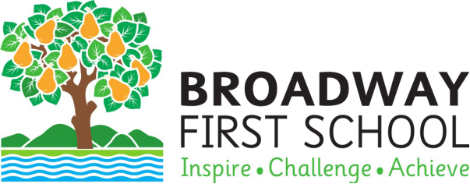

Post: Teaching Assistant
Pay: Dependent upon experience and qualifications
APPRENTICE £10,992 pro-rata
TA Level 1 (SCP 2-4) £16,847 - £17,380 pro-rata
TA Level 2 (SCP 5-6): £17,655 - £17,935 pro rata
Contract type: 30 hours per week, term-time only, temporary until the end of the 2026/27
academic year in the first instance.

Broadway First School has a rare opportunity to add a Teaching Assistant to our committed team. We are looking for a person with a passion for developing and inspiring children to achieve their very best. If you are dedicated, professional, creative and a real team player then we would love to hear from you. You may already hold a Teaching Assistant qualification supported by Maths and English qualifications at GCSE or equivalent level. We are also inviting applications from excellent individuals that would like to pursue an apprenticeship to gain a qualification on the job.

You will be predominantly class-based, working alongside excellent teaching staff to support learning for groups and individuals, delivering intervention programmes where required. This is a great opportunity to develop your skills further whilst being able to explore new interests in a school that is always looking to provide the best for its community.

The school received many complimentary comments in its most recent Ofsted report, recognising the ‘high-quality and wide-ranging curriculum’ at our school as well as the nurturing environment we have created.

The role is a temporary role for until the end of the 2026/27 academic year, although there is a strong possibility this will be extended for the right candidate. We welcome school visits so that you can see our wonderful school for yourself.

We can offer you:
- Children that want to be challenged and enthused
- A nurturing and happy school environment
- A close knit and supportive staff group who genuinely want the best for our children
- A school that believes in growing the skills and knowledge of staff
- The opportunity to make a real difference to our school and its children
- A wider network of support through our close ties within our school cluster

We would love you to join us if you…
- Believe children should feel safe, valued and listened to at school
- Have experience in schools or a keen interest in working with children as your chosen career
- Understand that children learn if different ways
- Want to plan sessions to meet the needs of all learners
- Have the motivation to make learning exciting across the whole curriculum
- Are passionate and committed to delivering the highest of standards
- Are a great team player willing to go the extra mile
- Are committed to further improving your own practice

Application deadline: 4pm, Monday 13th April 2026
Interview date: W/C Monday 13th or 20th April 2026
Start date: As soon as DBS and clearances are complete
We would encourage you to visit our school website, http://www.broadway.worcs.sch.uk as well as our Facebook page to learn more about the school. Visits to the school are warmly encouraged. Please contact the school to make an appointment. To request an application pack please email the school on office@broadway.worcs.sch.uk Only fully completed application forms will be considered. Only shortlisted candidates will be contacted.

The school is committed to safeguarding and promoting the welfare of children and young people and expects staff and volunteers to share this commitment. The school is committed to safer recruitment practice and pre-employment checks will be undertaken before any appointment is confirmed. This post is subject to an enhanced clearance by the Disclosure and Barring Service. Our Safeguarding Policy can be viewed here.

Broadway First School
Lime Tree Avenue
Broadway

Worcestershire
WR12 7BD

Phone: 01386 852485

Email: office@broadway.worcs.sch.uk Website: www.broadway.worcs.sch.uk

