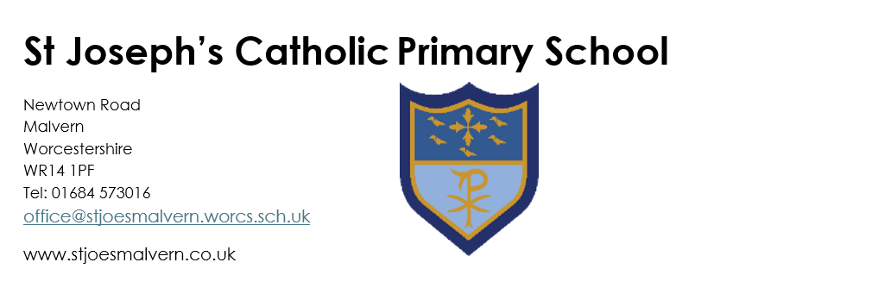
Caretaker Job Description & Person Specification

St Joseph’s Catholic Primary School

JOB DESCRIPTION

To maintain a clean, attractive, safe, secure and welcoming site through ad-hoc, routine and scheduled maintenance of buildings, grounds, fixtures and fittings.

RESPONSIBILITIES AND TASKS
Statutory Compliance Tasks

- Making and recording regular safety and compliance checks (such as water temperature, premises condition, fire extinguisher function, etc.)
- Regular visual inspections of premises accessibility, safety and condition.
- Maintenance of safety and condition records, such as asbestos register, Fire Safety Risk assessment, etc.
- Undertaking necessary training including safeguarding children, health & safety and other areas related to site management (asbestos management, fire awareness etc.)

Building Maintenance:

- Carrying out appropriate safety and operative repairs to the site either where identified through own condition checks or through referral from staff and with the approval of the headteacher.
- Carrying out preventative maintenance tasks like cleaning gutters, tidying storage facilities, sweeping leaves and organic litter, testing fire alarms, fire extinguishers, emergency lighting and emergency exits.
- Minor construction and “DIY” jobs, (such as putting up shelves) to including painting and basic decorating as needed.

Groundskeeping:

- Maintaining the school grounds including strimming overgrown borders, weeding and cutting back shrubs/ bushes and brambles.
- Ensuring walkways and surfaces are clear and slip-free, and snow & ice removal including gritting paths.

Professional relationships

- Liaising closely with the office about facilities management, premises management and ordering / receiving appropriate products and materials.
- Welcoming contractors and inspectors to the school and escorting around the site in the course of necessary works and statutory duties.
- Meeting with headteacher regularly to review compliance, any premises issues, progress of projects and ongoing concerns.

Post holders will be expected to be flexible in undertaking duties and responsibilities attached to their post and may be asked to perform duties which reasonably correspond to the general character of the post and are commensurate with its level of responsibility.
Overtime for longer and more complex tasks will be available by mutual agreement.

PERSON SPECIFICATION

 | Essential | Desirable
Qualifications | Good Numeracy and Literacy skills | A full driver’s license
Knowledge & Experience | - Experience that supports maintenance of an aspect of buildings or premises  - Experience that is transferrable to the role  - Knowledge and understanding of relevant policies/codes of practice – health and safety  - (e.g. COSHH, Fire safety, etc.)  - Ability to use a range of tools and equipment safely and effectively, ensuring safe handling and storage. | - Experience of working as part of a team.  - Experience of co-ordinating building projects and premises improvements.
Skills & Attributes | - Ability and willingness to work as part of a team  - Ability to use own initiative  - Ability to communicate effectively at all levels with internal and external personnel, contractors and suppliers  - Understanding of school roles and responsibilities  - Willingness to participate in training and development  - Able to use basic digital technology as part of their job (email, job recording, logging work etc.) | - Ability to carry out basic building repairs, painting, decorating and grounds maintenance.
Personal Qualities | - Highly motivated with high expectations, a positive attitude and a good sense of humour  - Excellent self-management skills  - Willing and able to work flexibly when needed.  - Excellent communication skills  - High level of personal integrity and a flexible approach to the role  - Approachable professional, who responds well to feedback and offers constructive advice.

