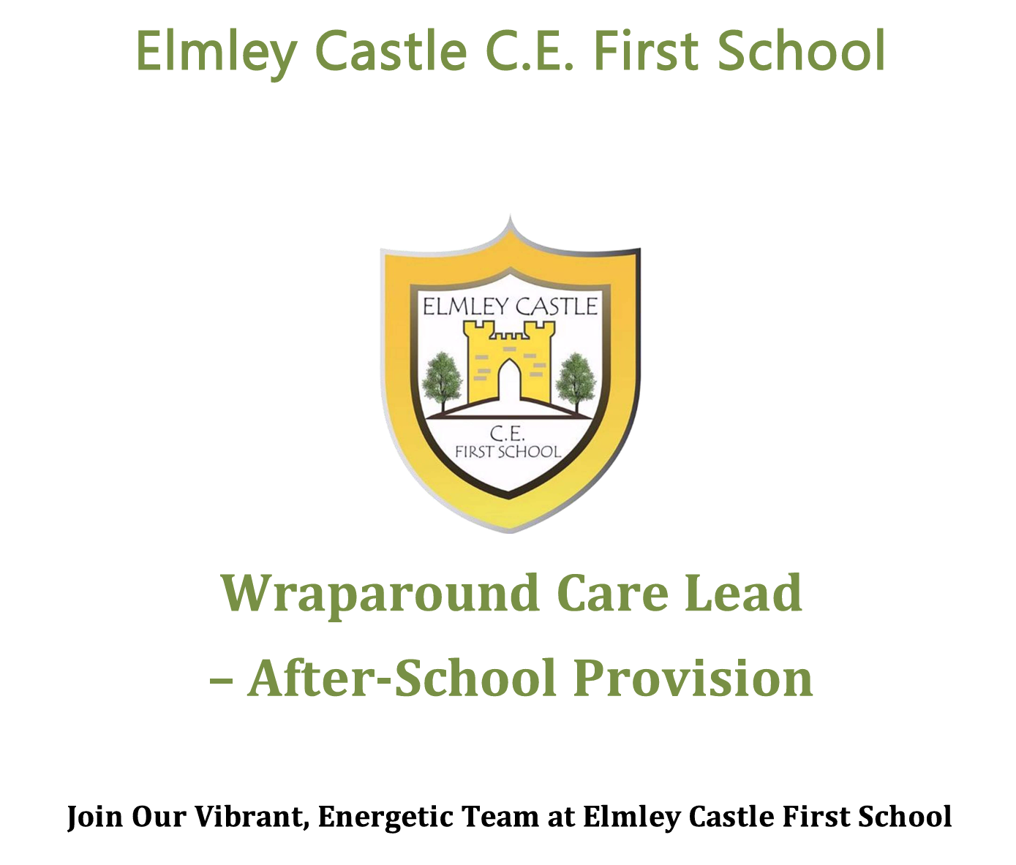
Wraparound Care Lead – Afterschool Provision
Start date September 2026

About the Role
We are looking for a caring, enthusiastic, and motivated Wraparound Care Lead to join our vibrant team at Elmley Castle First School. This is a fantastic opportunity to make a real difference in children’s lives while working in a warm, supportive environment.
As a Wraparound Care Lead, you will:
- Prioritise safeguarding above all else, ensuring the safety and welfare of every child.
- Lead high-quality, safe, and nurturing care for children aged 3–10 years.
- Create a fun and stimulating after-school environment with engaging play activities.
- Support children’s emotional wellbeing and encourage positive social interactions.
- Promote a caring, inclusive, and energetic atmosphere.
- Assist with snack preparation in line with food hygiene procedures.

What We’re Looking For
- A kind, energetic individual who enjoys working with young children.
- Enthusiasm, creativity, and a positive attitude.
- A team player committed to excellent safeguarding practices.
- Experience in childcare is helpful but not essential. Full training provided, including:
- Safeguarding and child protection
- Food hygiene
- First aid
- Play-work and activity planning

What We Offer
- A friendly, supportive school team
- Ongoing professional development
- A fun and varied working environment
- The opportunity to positively impact children’s after-school experience [

Qualifications and Pay
- TA3 (EYFS qualification) or higher preferred
- Paid at TA3 (SP7)

Working Hours
- 12.5 hours per week (term time only)
- Monday to Friday, 3:00pm – 5:30pm

Application Details
- Application Deadline: Tuesday 9th June 2026 (12:00 midday)
- Applications must be submitted on the official application form.

Safeguarding Statement
Elmley Castle C.E. First School is committed to safeguarding and promoting the welfare of children and young people. All staff and volunteers are expected to share this commitment.
Appointments are subject to:
- Enhanced DBS check
- Right to work in the UK
- Identity and qualification checks
- Satisfactory references

About Our School
Elmley Castle C.E. First School is a caring, supportive village school located in the rural Cotswold village of Elmley Castle, near Pershore and Evesham.

Vision and Values
“Let Your Light Shine!”
“You are the light of the world. A city set on a hill cannot be hidden.” — Matthew 5:14
At Elmley Castle C of E First School, we believe every child is a light in the world. We nurture growth, resilience, and kindness in a safe and welcoming environment.

BLISS Values
- Believe in yourself
- Love one another
- Inspire greatness
- Shine with kindness
- Serve with compassion

