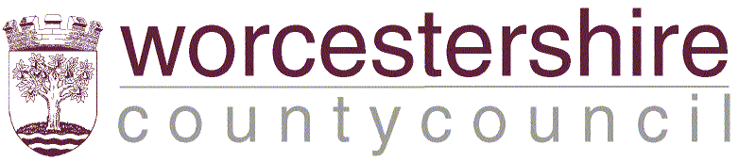

JOB DESCRIPTION

Job Title: Schools HR Coordinator
Directorate & Section/Unit: HR, Digital & Comms

Reporting to: Schools HR Consultancy Team Leader
Responsible for: N/A

Salary Grade: Scale 5
DMA Management Level: * Frontline
DMA Span of Control (Direct Reports): *

Our People Values:
To uphold and act in accordance with Worcestershire County Council's values:
- Customer Focus – Ensure delivery of a high-quality service which meets the needs of customers.
- Can Do Culture – Be proactive to achieve excellence, finding solutions and creative ways of working.
- Freedom within Boundaries - Make constructive change through cohesive decision making, ensuring services are responsive.

Purpose:

Co-ordination and provision of advice/sign posting on all Schools HR Consultancy policies, procedures and guidance. Promoting best practice and supporting the delivery of a high-quality HR Consultancy service for School and Academy customers.

Main Activities & Responsibilities:
- Provide a dedicated first point of contact for School customers to provide information, support, advice, guidance and solution-based sign posting.
- Deliver high quality, responsive and enthusiastic service to School customers via all communication mediums (telephone, email, teams/skype and face-to-face).
- Support the HRC team in the delivery of day to day first line advice & guidance in a timely, professional and resourceful manner.
- Direct advice & guidance queries/cases/change programmes which are above first point of contact signposting and resolution to the appropriate named school HRC contact.
- Assist HR Consultants with updating of policy, procedure and guidance documents including re-formatting of these documents.
- Co-ordinate the delivery of ad hoc projects/research/reporting as required.
- Undertake a developmental, small case load of low level / low risk absence and performance cases to be proactive and assigned project work as and when it arises.
- Maintain and update HRC shared files, CMS and ITrent data.
- Establish and monitor weekly/monthly trackers to ensure all policies/processes/projects are in line with timelines and review dates and raise any queries where legislation changes impact on current polices and processes.
- Input, extract, present and analyse data associated with HR activity and processes.
- To produce reports and management information as required within non-negotiable deadlines. To prepare and distribute information/correspondence.
- Support the delivery of developmental growth/ skills/knowledge enhancement of School leaders through support and training on HR/Employment related matters.
- Record key discussion and action points in Schools HR meetings.
- Take minutes in formal HR meetings for customers on an ad hoc basis
- To assist in the production of a regular HR updates to schools.
- Collate any feedback from customers received regarding the HRC team & escalate to manager proactively any issues raised by customers which are not being resolved.
- Produce redundancy estimates as required.
- Input OH referrals onto the OH Portal and alert HR Consultants to updates received.
- Attend CPD / training / Law updates as required.
- Develop and maintain effective relationships within the wider HR team for consistent and supportive teamwork approach.
- Work in partnership with suppliers and contractors e.g., payroll and occupational health to deliver best working practices and seamless transitions.

Generic Accountabilities:
- To maintain personal and professional development to meet the changing demands of the job, participate in appropriate training activities and encourage and support staff in their development and training.
- To undertake other such duties, training and/or hours of work as may be reasonably required, and which are consistent with the general level of responsibility of this job. To undertake health and safety duties commensurate with the job and/or as detailed in the Directorate’s Health and Safety Policy
- The duties described in this job description must be carried out in a manner which promotes equality of opportunity, dignity and due respect for all employees and service users and is consistent with the Council’s Equality and Diversity Policy

Contacts:
In all contacts the post holder will be required to present a good image of the Directorate and the County Council as well as maintaining constructive relationships.

Internal: Assistant Director, Education, School Improvement team, Core HR team, School Employee Services Team, Recruitment team, DBS team & staff across all directorates,

External: Customers; Senior leaders, governors and staff in maintained and academy schools, Occupational Health Provider (Spire Healthcare), Health Assured (EAP), Teacher Pensions, LG Pension Scheme team and other organisations as required

Additional Information:
- The Council reserves the right to alter the content of this job description, after consultation to reflect changes to the job or services provided, without altering the general character or level of responsibility.
- Some travel to schools and the office to attend team meetings will be required; so the ability to drive and own a car is essential
- Flexible approach to working hours as there may be a requirement to note take in meetings until 5pm/6pm on a very occasional basis.
- Reasonable adjustments will be considered as required by the Equality Act.

July 2026

