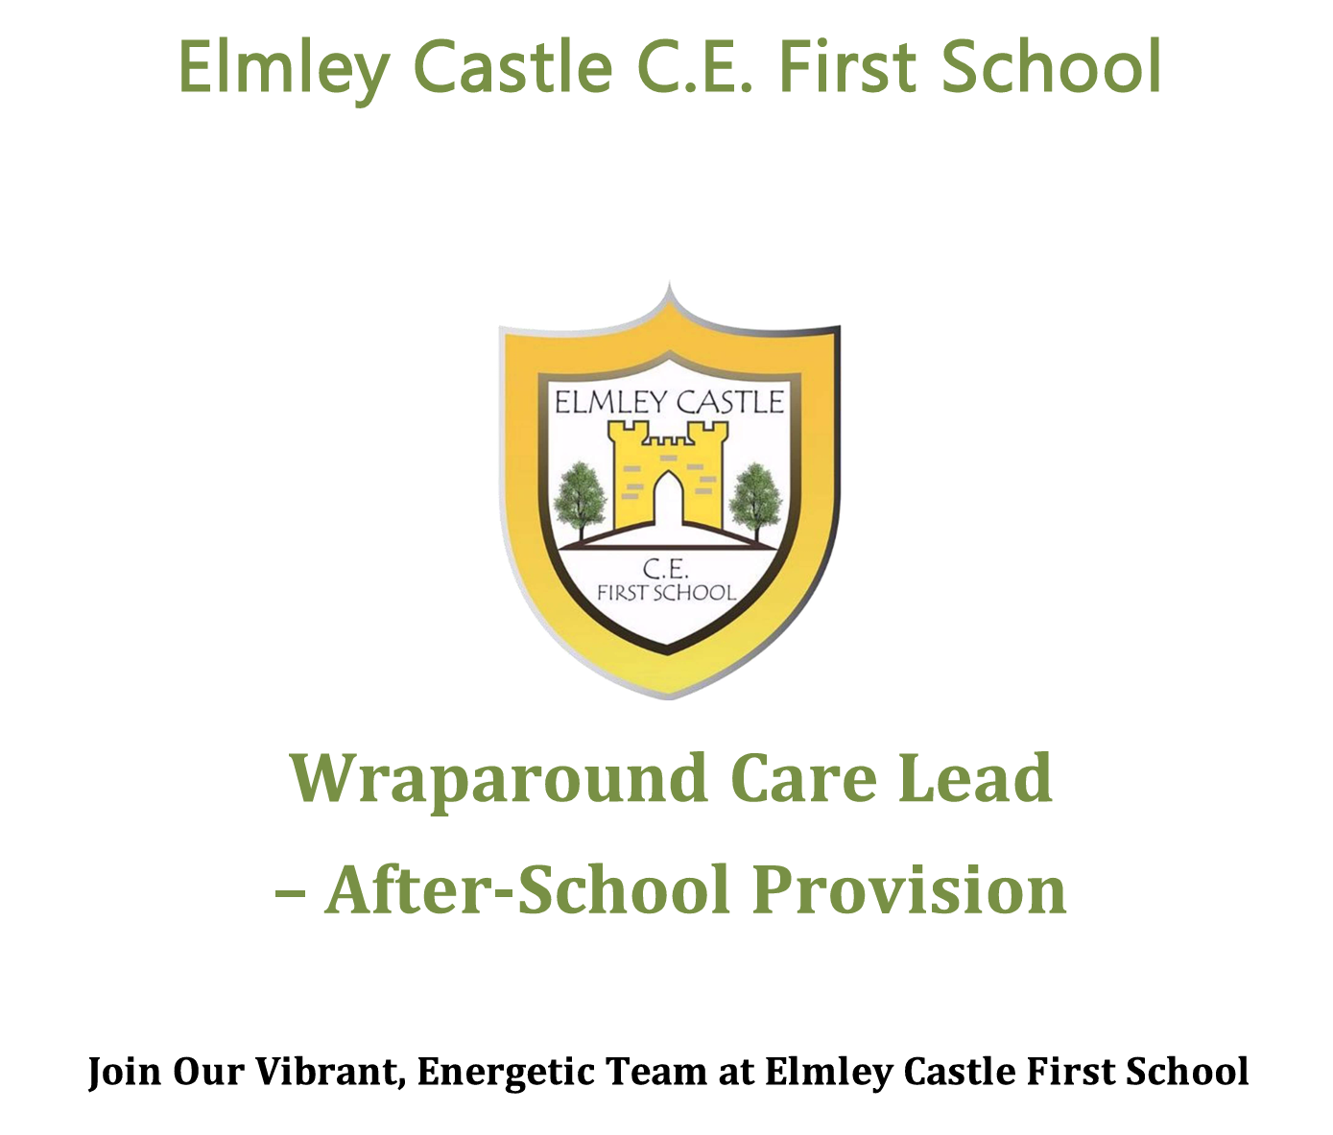

Wraparound Care Lead – Breakfast Club Provision
Start date September 2026

About the Role
We are looking for a caring, enthusiastic, and reliable Breakfast Club Lead to join our team at Elmley Castle First School. This is a fantastic opportunity to support children at the start of their school day, helping to create a calm, positive, and nurturing environment.
As a Breakfast Club Lead, you will:
- Prioritise safeguarding above all else, ensuring the safety and welfare of every child.
- Lead high-quality, safe, and nurturing before-school care for children aged 3–10 years.
- Create a welcoming and calm start to the day, supporting children’s emotional wellbeing.
- Provide engaging, low-key activities suited to the morning environment (e.g. quiet play, board games, reading).
- Promote positive behaviour and respectful interactions.
- Organise and serve a simple, healthy breakfast in line with food hygiene procedures.
- Ensure a smooth and safe transition from Breakfast Club into the school day.

What We’re Looking For
- A kind, calm, and reliable individual who enjoys working with young children.
- A positive, organised, and proactive approach.
- A team player committed to excellent safeguarding practices.
- The ability to create a nurturing and structured start to the day.
Full training provided, including:
- Safeguarding and child protection
- Food hygiene
- First aid
- Play-work and activity planning

What We Offer
- A friendly, supportive school team
- Ongoing professional development opportunities
- A rewarding role supporting children’s wellbeing and readiness for learning
- A calm and enjoyable working environment

Qualifications and Pay
- TA3 qualification (EYFS or equivalent) desirable
- Paid at TA3 (SP7)

Working Hours
- Approx. 5–7.5 hours per week (term time only – adjust as needed)
- Typical hours: 7:30am – 9:00am, Monday to Friday
(Hours can be adjusted to meet school needs.)

Application Details
- Application Deadline: Tuesday 9th June 2026 (12:00 midday)
- Applications must be submitted on the official application form.

Safeguarding Statement
Elmley Castle C.E. First School is committed to safeguarding and promoting the welfare of children and young people. All staff and volunteers are expected to share this commitment.
Appointments are subject to:
- Enhanced DBS check
- Right to work in the UK
- Identity and qualification checks
- Satisfactory references

About Our School
Elmley Castle C.E. First School is a caring, supportive village school located in the rural Cotswold village of Elmley Castle. We pride ourselves on fostering a nurturing, inclusive, and community-focused environment.

Vision and Values
“Let Your Light Shine!”
At Elmley Castle C of E First School, we believe every child is a light in the world. We nurture growth, resilience, and kindness, creating a safe and welcoming space for all.

BLISS Values
- Believe in yourself
- Love one another
- Inspire greatness
- Shine with kindness
- Serve with compassion

